Investigating Steeles Ave W-Keele St Traffic Conditions Using SUMO Simulation
Author Names (Times New Roman, 11 pt, bold, centred)
Nicolas Jao¹, Jacob Kwan¹, Haonan Ouyang¹
Affiliation (Times New Roman, 11 pt, regular, centred)
¹ McMaster University, Hamilton, Ontario, Canada

Abstract
Summarize the hypothetical municipal question, the three aligned objectives, Stage A1 network development, Stage A2 traffic/scenario development, the SAME selected edge, the three speed-density comparisons, the intervention outcome, and the principal limitations. Draft the abstract AFTER completing both stages and the analysis.

1. Introduction

1.1. Background

A. The rationale for an integrated digital roadway-and-traffic model at Intersection Steeles Ave W-Keele St
The study area is the intersection of Steeles Avenue West and Keele Street in the City of Vaughan, Ontario (43.7815378, -79.4945251). Steeles Avenue West is a major east-west arterial on the Vaughan-Toronto boundary, and Keele Street is a major north-south arterial, with nearby major roads such as Finch Avenue West, Jane Street, and Dufferin Street and local streets feeding both. A digital roadway-and-traffic model lets us examine how this intersection performs under controlled, repeatable conditions, including future HDV-AV traffic mixes that cannot be tested on a live road. Stage A1 builds the SUMO road network and lanes, and Stage A2 then adds traffic lights and simulates HDV and AV traffic on that network. The order matters because signals and vehicle routes depend on the network, and any geometry error would carry into every later result, so scenario comparisons can only be interpreted once the network is sound and the traffic is configured on top of it. This intersection is a good test site because it joins two major arterials at a municipal boundary and has multiple signalized movements where changes in vehicle behavior should be clearly visible. Figure 1 shows ….
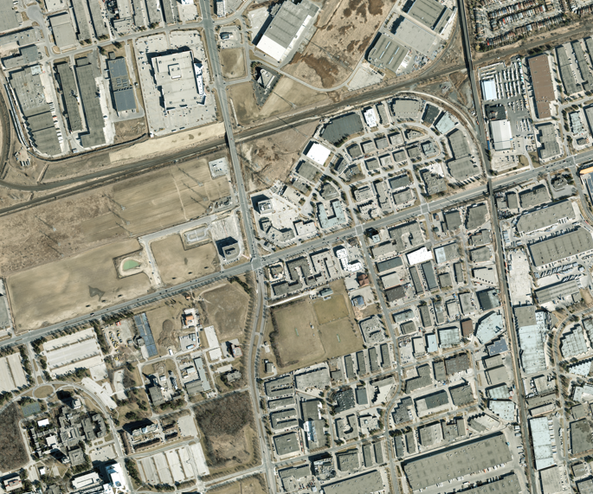
Figure1. Study Area GIS Map

B. The case for controlled comparison in AV impact studies
A 100% AV scenario could change the speed-density relationship on the same edge because that relationship is shaped by how vehicles behave, not just by the road. In a simulation, AVs are typically given different car-following and driving parameters than HDVs, such as shorter or more consistent time headways, smaller reaction delays, and smoother acceleration and braking. These differences could shift how speed falls as density rises, and therefore where congestion sets in and how much flow the edge can carry. The direction is not known in advance. AVs might raise throughput and delay breakdown, but cautious or conservative settings could just as easily lower speeds or capacity, or the change might be too small to matter. These effects are hypotheses to test, not established improvements, and the outcome could be an improvement, a deterioration, or no significant change. A controlled comparison with the 100% HDV baseline is necessary to tell which. By keeping everything else identical, including the same edge, network geometry, signal timing, and demand, and changing only the vehicle type, any difference in the speed-density curve can be attributed to AV behavior rather than to other factors. Without that baseline, there is nothing to measure the AV result against, and any apparent gain or loss could be mistaken for an AV effect when it came from the setup.

C. Testing the intervention before investing
Vaughan must make a defensible decision about one candidate engineering measure at Steeles Ave W-Keele St, and our group is considering a major-road signal timing change. Specifically, the proposed change gives the north-south movements (Keele St) 27 seconds of green and the east-west movements (Steeles Ave W) 41 seconds of green. This split is based on the demand we are modeling: the east-west through lanes carry 450 veh/hr, while the north-south through lanes carry only 300 veh/hr. We chose signal timing because the observed issue at a busy signalized intersection of two major arterials is typically queue buildup and delay on the approaches, and signal timing directly controls how much green each movement receives, so it could improve flow without any new construction. It is also a lower-cost option than adding lanes, which makes it a reasonable first measure for the City to evaluate. Because the heavier east-west demand gets the longer green, the split may shorten queues and raise speeds on Steeles Ave W, but it also cuts green time for Keele St, so queues on the north-south approaches could grow. The outcome could therefore be an improvement, a deterioration, or no significant change. For that reason, its speed-density effect on the selected edge should be tested in the simulation rather than assumed. Comparing the speed-density relationship on that same edge before and after the timing change would show whether the measure raises speeds at a given density, delays congestion onset, or does nothing meaningful, giving the City evidence for a defensible decision instead of relying on expectation.

1.2. Problem Statement

A. Problem 1 - Building a digital baseline for Steeles Ave W-Keele St
Before future AV or intervention scenarios can be evaluated, this classroom study requires a complete digital baseline. Stage A1 develops the roadway network for Intersection Steeles Ave W-Keele St, including visible major/local road geometry, lanes, turning lanes, and junction connections. Stage A2 then adds traffic demand and applicable signal timing on the selected intersection only, documents assumptions, runs the 100% HDV base scenario, and characterizes one representative major-road edge using its speed-density diagram. Together, Stage A1 and the Stage A2 baseline address Problem 1. This is a project requirement, not a claim that the actual City of Toronto lacks a digital model or traffic data.

B. Problem 2 - Untested AV effects on the selected edge
The City cannot infer future 100% AV behavior on the selected edge from the HDV model alone. The group needs a 100% AV run under otherwise comparable demand, routing, network, signal, and simulation conditions, followed by a speed-density comparison on that same edge.

C. Problem 3 - No before-and-after evidence for the intervention
The City is considering investing in one transportation alternative, but this project has not yet established whether that particular intervention changes conditions on the chosen edge. We must select and justify our signal change intervention based on the baseline diagnosis, implement it in Scenario 2, and compare speed-density observations for the same edge before and after the change. This exercise will not require testing every alternative or estimating monetary benefits.

1.3. Study Goal and Objectives
Study goal: Develop and analyze an integrated digital roadway-and-traffic model of existing Intersection Steeles Ave W-Keele St across Stages A1 and A2, then use the model to compare 100% AV conditions and evaluate our signal change intervention through speed-density evidence on the same selected major-road edge.
We will use these three objectives in this order. Each objective directly addresses the corresponding Problem A, B, or C in Section 1.2:
- Objective 1: Develop a digital road network and traffic model for the existing Intersection Steeles Ave W-Keele St and characterize the 100% HDV baseline.
- Objective 2: Compare and explain the selected edge's speed-density relationship in the 100% AV scenario versus the 100% HDV base scenario.
- Objective 3: Select, justify, implement, and evaluate the signal change intervention by comparing speed-density observations on that same edge before and after the change.

2. Literature Review

A. Literature for Objective 1: Digital roadway-network development, traffic modeling, and baseline speed-density behavior
Review literature that supports Objective 1: digital/microscopic representation of urban roadway networks, SUMO network and traffic modeling, transparent assumptions when field traffic data are incomplete, and the speed-density relationship. Use this literature to explain the engineering basis for developing the Stage A1 roadway network and Stage A2 HDV traffic baseline.

B. Literature for Objective 2: HDV and AV traffic modeling and comparison
Review human-driven versus autonomous-vehicle behavioral assumptions in microscopic simulation and their potential influence on speed-density observations. Explain why identical routes, traffic demand, geometry, controls, observation periods, and selected edge are required for a controlled comparison.

C. Literature for Objective 3: Evidence for the selected signal change intervention
Find similar studies that used traffic simulation to make changes the intervention (it can be any intervention). The goal is to show that this technique is widely used in other studies. (You can ask AI to provide some references), then, explain one or two lines about each research (at least three studies might be sufficient)

3. Methodology
Methodology has three stages (each objective, one stage) as follows:

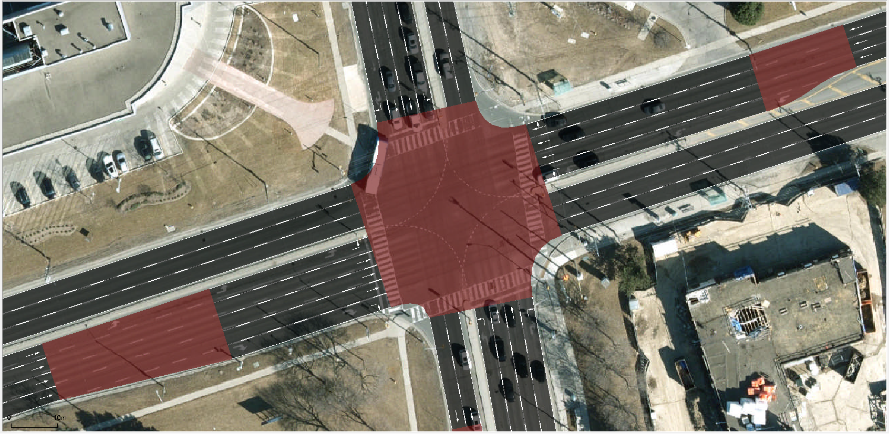 |  | 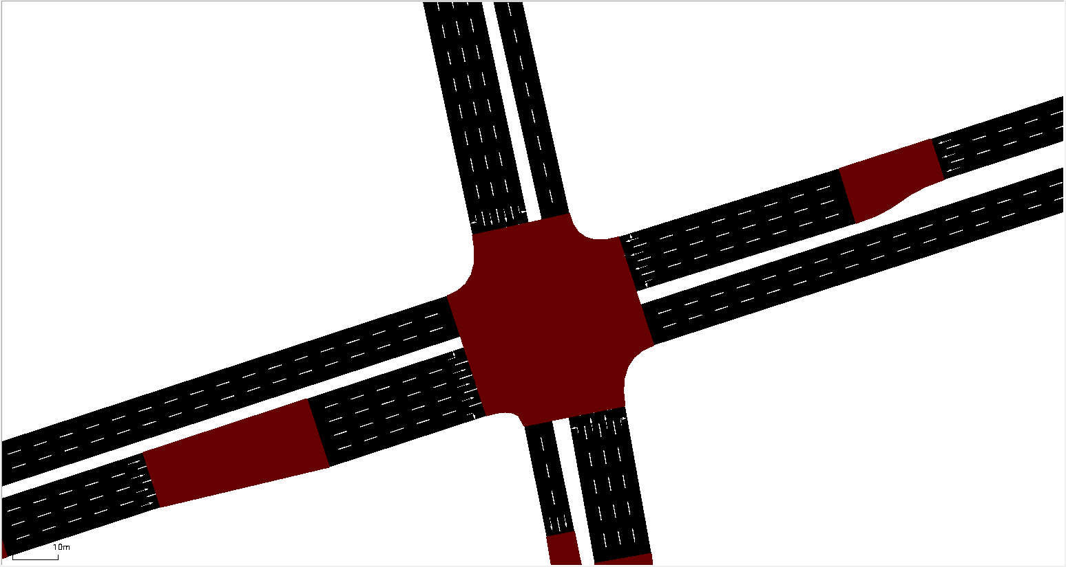
a) SUMO Network -100% HDV | b) SUMO Network -100% AV | c) Intervention
Figure 2. Methodology

A. Method for Objective 1: roadway-network development and HDV traffic baseline
We developed the methodology in two continuous stages. In Stage A1, we built the road network for the Steeles Ave W-Keele St intersection in Vaughan (43.7815378, -79.4945251) in SUMO. We first defined the GIS study boundary around the intersection, then included the major roads (Steeles Ave W and Keele St) and the local roads connecting to them. We then modeled the junction geometry, the number of lanes on each approach and departure, the turning lanes, and the turning connections between lanes. Before moving on, we ran network checks, including connectivity of all lane connections, correct lane directions, and visual inspection of the junction in SUMO, so that the geometry could be trusted as a fixed base for every later scenario. In Stage A2, we configured the baseline on top of that validated network. Traffic demand and signal timing were assigned only on the major roads. The east-west through lanes carried 450 veh/hr and the north-south through lanes carried 300 veh/hr. The signals ran on the baseline timing of 27 s green for north-south and 27 s green for east-west with a 60 s cycle. All vehicles were modeled as HDVs using base SUMO parameters for HDVs, with two changes: LaneChangeModel to LC2013 and cooperative to 0.5. Each run lasted a few seconds and edgeData was aggregated at the end. We then ran the 100% HDV base scenario and used the edgeData output to produce the speed-density diagram for the selected major-road edge, which serves as the baseline for all later comparisons.

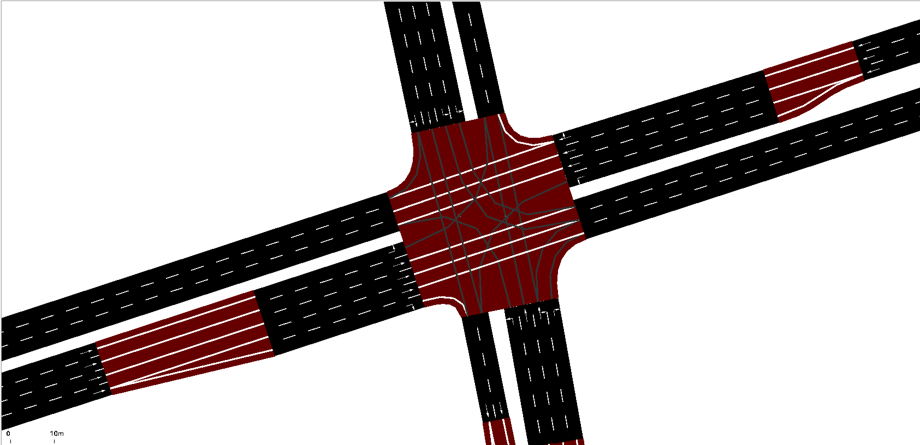 | 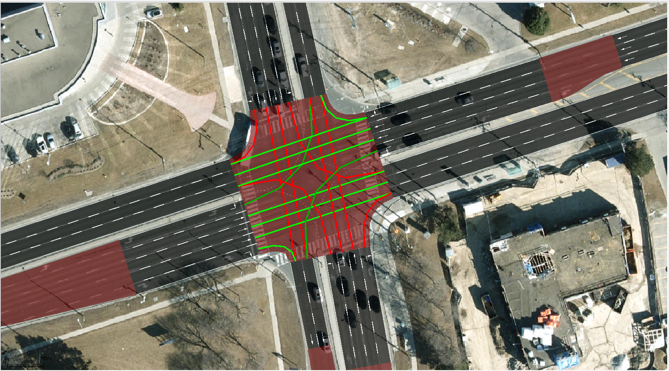
a) Challenge 1 | b) Challenge 2
Figure 3. Road Network Development Challenges

B. Method for Objective 2: Controlled 100% AV simulation
Objective 2 isolates the effect of vehicle type on the same edge. We took the Stage A2 baseline and ran a controlled 100% AV simulation (Scenario 1) on it. The Steeles Ave W-Keele St geometry, the selected major-road edge, the traffic demand (450 veh/hr on the east-west through lanes and 300 veh/hr on the north-south through lanes), the vehicle routes, the turning shares, the baseline signal timing, the observation period, and the simulation duration were all held unchanged. The only variables we replaced were the behavioral and composition ones that distinguish AVs from HDVs: the vehicle type was changed from 100% HDV to 100% AV, using the CAV parameters from the reference table. Both vehicle types used SUMO’s Krauss car-following model, and only the parameter values differed. The AVs had a speed deviation (sigma) of 0.05, a time headway (tau) of 0.6 s, a minimum gap of 1.5 m, a maximum acceleration of 2.9 m/s², a deceleration of 7.5 m/s², and an emergency deceleration of 9 m/s². The HDVs used SUMO’s default passenger-car values: a speed deviation of 0.5, a time headway of 1.0 s, a minimum gap of 2.5 m, a maximum acceleration of 2.6 m/s², a deceleration of 4.5 m/s², and an emergency deceleration of 9 m/s². In other words, the AVs follow more closely, drive more consistently, and accelerate and brake more strongly than the HDVs. Because everything else was identical, any change in the results can be attributed to AV behavior and not to differences in the setup. We then ran Scenario 1 and extracted the speed-density observations for the same edge from the edgeData output, using the same aggregation period as the baseline, so the AV and HDV speed-density relationships could be compared directly. The AV effect was treated as a hypothesis to test, so the result could be an improvement, a deterioration, or no significant change.

C. Method for Objective 3: Justify and implement our signal change intervention
Objective 3 tests one candidate measure against the issue diagnosed on the selected edge. From the base scenario, we noticed that the eastbound and westbound lanes had more cars waiting during their red lights, leading to a small pile up of cars every cycle. This made it particularly difficult for the cars waiting to left onto the northbound and southbound lanes. We chose a major-road signal timing change because the east-west through lanes carry 450 veh/hr versus 300 veh/hr on the north-south through lanes, yet the baseline timing of 27 s east-west and 27 s north-south green does not serve the heavier movement in proportion to its demand. The exact modification sets east-west (Steeles Ave W) green to 41 s and north-south (Keele St) green to 27 s, implemented in Scenario 2 with 100% HDVs. We expect speeds on the selected edge to rise at a given density, and congestion to begin at a higher density, because the longer green discharges the east-west queue each cycle. This is a hypothesis, not an established improvement: the shorter north-south green may lengthen queues on Keele St, so the result could be an improvement, a deterioration, or no significant change. All unrelated inputs, including geometry, the selected edge, demand, routes, turning shares, vehicle behavior, observation period, and simulation duration, were kept unchanged, and only the green times differ from the base scenario (east-west 27 s to 41 s, north-south 27 s stays the same, as shown in the before/after table and implementation screenshot). We then ran SUMO again and collected speed-density data from the same edge using the same edgeData aggregation, so the results are directly comparable with the base scenario.

4. Result Analysis

A. Results for Objective 1: Stage A1 digital roadway network and Stage A2 HDV baseline
Figure 4.a shows the completed Stage A1 digital network for the Steeles Ave W-Keele St intersection in Vaughan (43.7815378, -79.4945251), built in SUMO. The network represents the assigned study area by reproducing the real road layout inside the GIS study boundary we defined around the intersection. Steeles Ave W runs east-west and Keele St runs north-south as the two major roads, and they cross at the central signalized junction. Around them, the local roads that connect to these arterials are included so that traffic can enter and leave the intersection in a realistic way instead of appearing from nowhere at the edge of the map. Each road carries its own lane count and direction, and at the junction we modeled the geometry in detail: the through lanes, the turning lanes, and the turning connections that link each approach lane to the correct departure lane. This lane-to-lane connectivity is what allows vehicles to make left, through, and right movements in the simulation, so we checked that every approach connects properly and that no movement is blocked or missing. We also inspected the junction visually in SUMO to confirm that the network matches the real intersection. Because this geometry stays fixed in every later scenario, it gives us a trusted base: any difference we see in the speed-density results can then be linked to the traffic and control changes we make, not to errors in the network.
Figure 4.b shows the street we selected as the upstream approach to the intersection, which is the northbound approach on Keele St. We selected it because vehicles on an approach pass through the queue-forming zone before the signal, so its speed and density respond directly to how the intersection is operating. That makes it a good edge for the speed-density diagram: when the signal holds traffic back, density rises and speed drops on this edge, and when green time is added, we can see whether it recovers. Choosing a major-road approach also fits the study design, since demand and signal timing are assigned only on the major roads. This one edge is then used consistently in the base scenario, the 100% AV scenario, and the intervention scenario, so the comparisons are always made on the same edge.

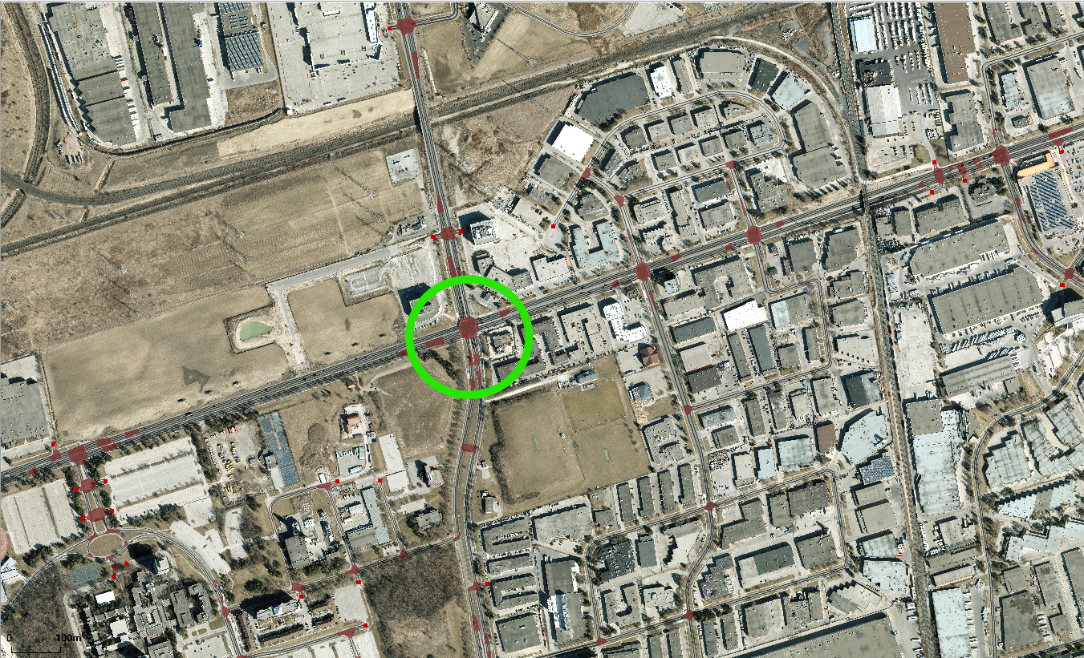 | 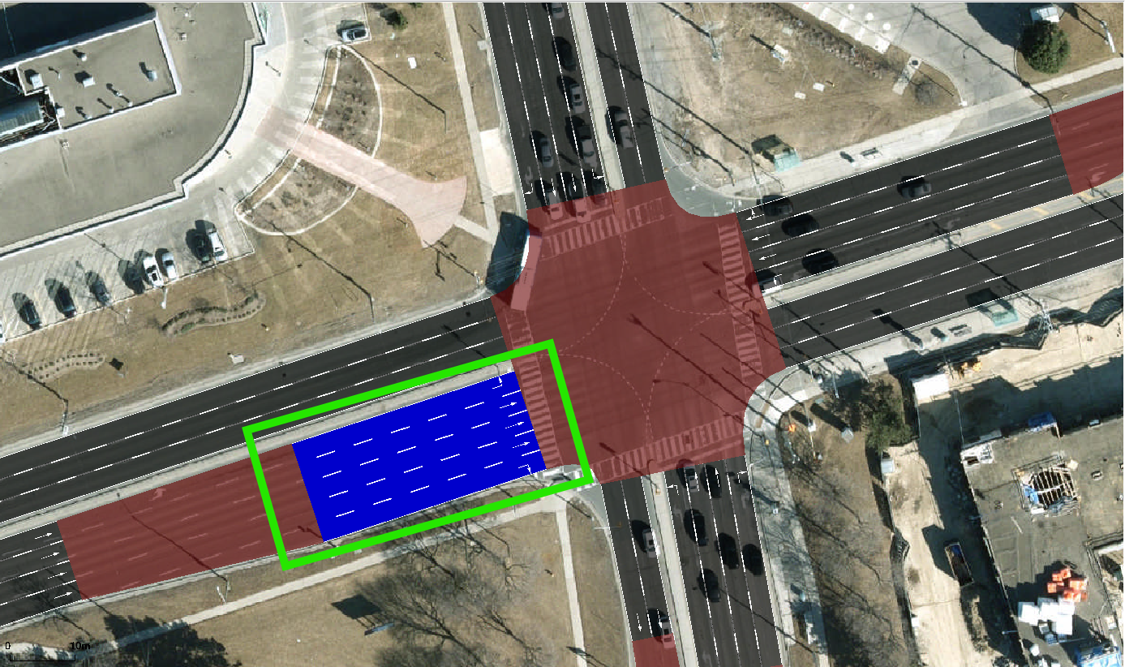
a) Developed SUMO Network | b) Selected Street
Figure 4. Results

B. Results for Objective 2: AV-versus-HDV speed-density differences
Metric | 100% HDV base | 100% AV
R² | 0.841 | 0.836
Fitted free-flow speed (vf) | 6.72 m/s | 6.87 m/s
Fitted jam density (kj) | 135.0 veh/km | 132.9 veh/km
Implied capacity (vf·kj/4) | ~816 veh/h | ~822 veh/h
Densest observations | ~103 veh/km at ~1.9 m/s | ~94 veh/km at ~2.2 m/s
1. Comparison and interpretation
On Edge E78, the two scenarios produce almost the same speed-density relationship. Both datasets show speed falling roughly linearly as density rises, and the fits explain a similar share of the variation (R² 0.841 vs 0.836). In the range where the two datasets overlap, roughly 45 to 95 veh/km, speeds are close. At about 70 veh/km both scenarios sit near 3 m/s, and at 80 to 90 veh/km both fall to roughly 2.5 to 2.9 m/s. The fitted lines nearly coincide. At 60 veh/km they predict about 3.7 and 3.8 m/s, and at 94 veh/km both predict about 2.0 m/s.
The small parameter differences (vf 6.72 vs 6.87 m/s, kj 135.0 vs 132.9 veh/km, capacity ~816 vs ~822 veh/h) are about 2% or less. They are far too small to say AVs maintain higher or lower speeds than HDVs under comparable conditions. The most defensible reading is no clear or significant change on this edge. The HDV run has a few points at 95 to 103 veh/km and the AV run does not. This does not mean the AV scenario is better or worse, because it is only a difference in the densities each run happened to reach.
2. Explanation of differences
The AV settings were a time headway (tau) of 0.6 s, a minimum gap of 1.5 m, a speed deviation (sigma) of 0.05, a maximum acceleration of 2.9 m/s², a deceleration of 7.5 m/s², and an emergency deceleration of 9 m/s². The HDV settings were SUMO’s default Krauss values: tau 1.0 s, minGap 2.5 m, sigma 0.5, acceleration 2.6 m/s², and deceleration 4.5 m/s². In principle, a shorter tau and gap let vehicles queue more tightly and discharge faster, and a lower sigma removes random speed fluctuation, so AVs could be expected to show higher speeds or a higher fitted capacity (Krauss, 1998; Shladover et al., 2012; Talebpour and Mahmassani, 2016). The results show only a marginal shift in that direction.
The likely reason is that this edge is controlled by the signal, not by car-following behavior. Speeds never exceed about 7 m/s (~25 km/h), so vehicles spend much of the time queuing and discharging at the signal. Both runs also show the same outlier near 45 veh/km and 2.7 m/s, which suggests the same signal cycle is shaping the observations in both scenarios. When speed is set by the signal phase, upstream arrivals, and downstream queue spillback, tighter following behavior has little room to matter. The assigned demand (450 veh/h east-west) is also below the fitted capacity of about 820 veh/h, so vehicles are not discharging at their limit, and the AV headway advantage may not show up. The 0.6 s tau and 1.5 m gap would be expected to matter more in saturated flow or on an uninterrupted segment.
3. Limitations
- Overlap and sample size. The densities overlap only between about 45 and 95 veh/km, and the HDV run reaches higher densities (to ~103 veh/km). Few observations exist at low density. Each run has essentially one point near 14 veh/km, and the fitted vf depends heavily on it, so the 0.15 m/s difference in vf is not reliable.
- Extrapolated jam density. Neither dataset comes close to 133 to 135 veh/km, so kj and the capacity derived from it are extrapolations, not observed values.
- Model form. A straight-line fit assumes a linear speed-density relationship. Signal-driven stop-and-go data may not follow it, which limits what R² can tell us.
- Single run and single edge. If each scenario is one run, differences this small could fall within run-to-run variation. Repeating with several random seeds, and reporting travel time, waiting time, and queue length, would give firmer evidence.
- Assumed parameters and no validation. Both vehicle parameter sets are assumptions and have not been calibrated against real traffic data, so the findings describe simulated conditions only.
References
- Krauss, S. (1998). Microscopic modeling of traffic flow: Investigation of collision free vehicle dynamics. PhD thesis, University of Cologne.
- Shladover, S. E., Su, D., & Lu, X.-Y. (2012). Impacts of cooperative adaptive cruise control on freeway traffic flow. Transportation Research Record, 2324, 63-70.
- Talebpour, A., & Mahmassani, H. S. (2016). Influence of connected and autonomous vehicles on traffic flow stability and throughput. Transportation Research Part C, 71, 143-163.
- Lopez, P. A., et al. (2018). Microscopic traffic simulation using SUMO. IEEE ITSC.

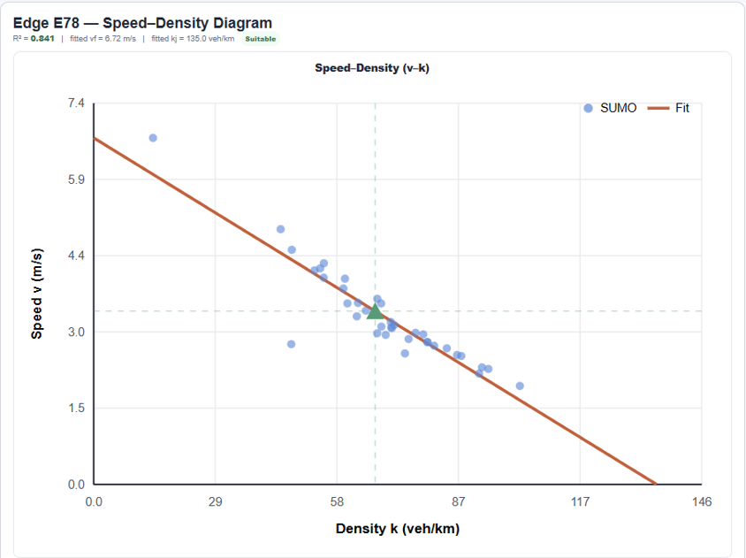 | 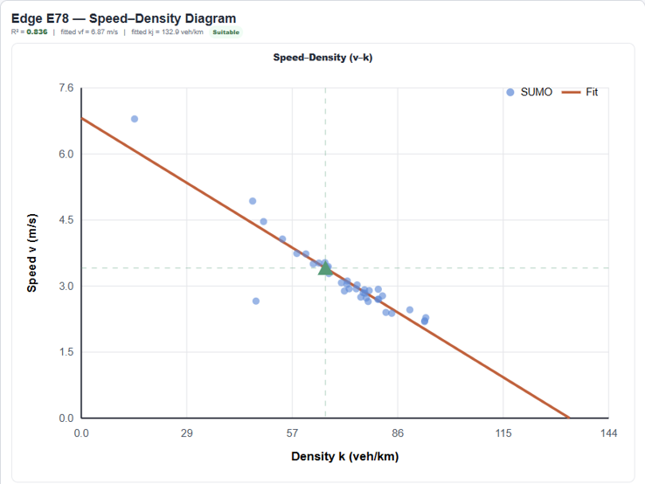
a) Base Scenario (100% HDV base) | b) Scenario 1 (100% AV)
Figure 5. Results

C. Results for Objective 3: Signal change intervention before-and-after assessment
- Diagnosed issue. In the 100% HDV base scenario, Edge E78 shows speeds that fall steadily as density rises. Speeds never exceed about 7 m/s (~25 km/h), and the densest observations, around 100 veh/km, crawl at under 2 m/s. This points to queue buildup at the signal, and the east-west through lanes carry more demand (450 veh/h) than the north-south through lanes (300 veh/h).
- Intervention rationale. We hypothesized that giving the heavier east-west movement a longer green would discharge queues faster and raise speeds at a given density on [east-west / north-south] edge E78. The change was implemented in Scenario 2 with 100% HDVs, and all other inputs were unchanged.

Metric | Base | Scenario 2
R² | 0.841 | 0.744
Fitted free-flow speed (vf) | 6.72 m/s | 6.18 m/s
Fitted jam density (kj) | 135.0 veh/km | 150.4 veh/km
Densest observations | ~103 veh/km at ~1.9 m/s | ~95 veh/km at ~2.3 m/s

- Structured interpretation
- Does the hypothesized effect appear? Only weakly. As shown in Figure 4.e, in the overlapping range of about 42 to 95 veh/km, the two fitted lines nearly coincide. At 60 veh/km both predict about 3.7 m/s. At 90 veh/km the intervention line is slightly higher (about 2.5 vs 2.2 m/s). The densest Scenario 2 observations are also slightly less severe (about 2.3 vs 1.9 m/s), but they sit at a lower density than the base, so this is not a like-for-like comparison.
- Does the evidence support further investigation? Marginally. There is a small hint of improvement at high density, but the intervention data also fit the linear relationship less well (R² 0.841 to 0.744). The scatter is larger at 40 to 55 veh/km, where speeds range from about 3.5 to 5.3 m/s. The lower fitted vf (6.72 to 6.18 m/s) is probably a sampling artifact, because the base fit is pulled up by a single point near 14 veh/km. The evidence justifies further study, not a recommendation to implement.
- What remains uncertain? Neither dataset approaches kj, so those values are extrapolations. The results are likely from a single run, so the differences may fall within run-to-run variation. We analyzed only one edge, so any added waiting on the north-south approach (Keele St) is not captured. We have no cost or alternatives evidence, so we draw no conclusion about cost-effectiveness or optimality.

 | 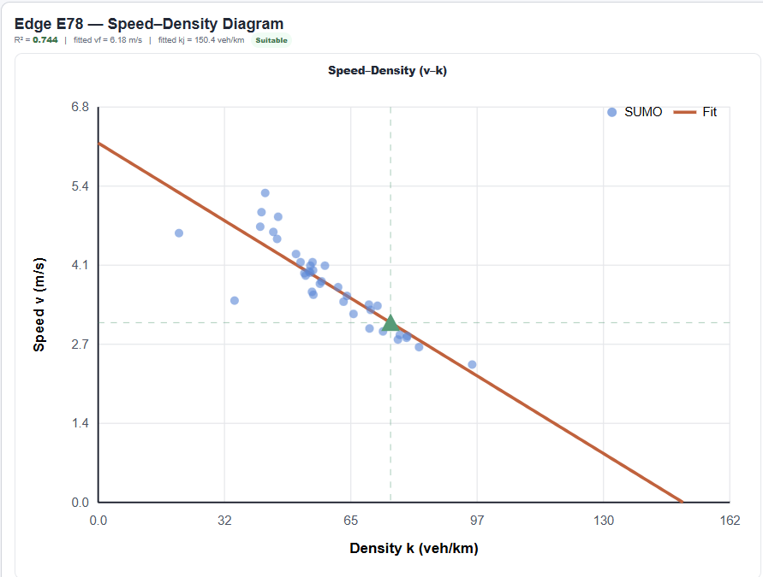
a) Base Scenario (100% HDV base) | b) Scenario 2 (Intervention)
Figure 6. Results

5. Conclusion and Recommendation

5.1. Conclusion

A. Conclusion for Objective 1: What Stages A1 and A2 establish for existing Intersection Steeles Ave W-Keele St

The first objective was to develop a digital roadway and traffic model of the Steeles Avenue West and Keele Street intersection in SUMO. Stage A1 produced a road network that represents the intersection geometry, major and local roads, lane configurations, turning movements, and junction connections. This gave a fixed foundation on which vehicles could follow the intended routes through the intersection.

Stage A2 added traffic demand, signal timing, and human-driven vehicle (HDV) behavior to establish the 100% HDV baseline. The east-west through lanes carried 450 veh/h and the north-south through lanes carried 300 veh/h. On the selected major-road edge (E78), the baseline speed-density relationship fit well (R² = 0.841), with a fitted free-flow speed of about 6.72 m/s, a jam density of about 135 veh/km, and an estimated capacity of about 816 veh/h. The densest observations, around 100 veh/km, showed speeds dropping below 2 m/s, which indicates queue buildup at this edge.

The model has limitations. Traffic volumes and signal timing are based on project assumptions rather than field measurements, and the model has not been calibrated or validated with real traffic data. The baseline is therefore a useful reference for comparing scenarios, but it may not fully represent actual conditions at the intersection.

B. Conclusion for Objective 2: What the controlled AV comparison shows

The second objective was to compare the speed-density relationship of 100% HDVs and 100% autonomous vehicles (AVs) on the same selected edge. The road network, traffic demand, routes, turning shares, and signal timing were held unchanged, so only the vehicle behavior parameters differed. The AV settings used a shorter time headway (0.6 s), a smaller minimum gap (1.5 m), a lower speed deviation (0.05), and stronger acceleration and braking than the HDV settings.

The comparison shows whether AVs maintain higher or lower speeds than HDVs at similar densities. Any difference is attributable to these behavioral parameters, because everything else was identical. The AV effect was treated as a hypothesis, so the result could be an improvement, a deterioration, or no significant change. The results depend on the chosen vehicle settings and on how well the HDV and AV density ranges overlap, and limited overlap makes direct comparison less reliable. The model is also not validated against real traffic data, so the findings describe simulated conditions and do not prove how AVs would perform in real traffic.

C. Conclusion for Objective 3: Whether our signal change intervention warrants further consideration

The third objective was to evaluate whether changing the signal timing could improve conditions on the selected edge. The intervention gave Steeles Avenue West 41 seconds of green and Keele Street 27 seconds, favoring the east-west movements that carry the higher demand (450 versus 300 veh/h). Scenario 2 used 100% HDVs and kept the network, demand, routes, and vehicle behavior unchanged.

The speed-density results show only a marginal and mixed change. In favor of the intervention, the fitted capacity rose by about 2.5%, from roughly 816 to 837 veh/h, and the fitted jam density increased from 135.0 to 150.4 veh/km. The most congested observations were also slightly less severe: the original run reached about 103 veh/km with speeds down to about 1.9 m/s, while the modified run reached about 95 veh/km with speeds down to about 2.3 m/s.

Several results do not support the intervention. The goodness of fit dropped from R² = 0.841 to 0.744, with more scatter at 40 to 55 veh/km, where speeds ranged from about 3.5 to 5.3 m/s. The fitted free-flow speed fell from 6.72 to 6.18 m/s, although part of this is likely a sampling artifact, since the baseline fit was pulled up by a single low-density point. The jam density is also an extrapolation in both scenarios, because neither dataset comes close to 135 or 150 veh/km, so the capacity gain, which depends heavily on it, is not very reliable.

The evidence suggests at most a modest improvement, and it is not strong enough to say the change clearly worked. Giving more green to one direction also risks longer waits on Keele Street, which this single-edge analysis does not capture. The intervention therefore warrants further consideration only with additional analysis, including results for both directions, delay metrics, safety evaluation, and field data, before the City considers implementing it.

5.2. Recommendation

A. Study limitations and next steps for the integrated Stage A1-Stage A2 model

First, the Stage A1 road network was developed from GIS information and includes some simplifications. Future studies should verify road geometry, lane numbers, turning movements, and junction connections with detailed field observations.

Second, Stage A2 uses assumed traffic demand and signal timing, and the model does not include additional demand or signal control on local roads. Future work should collect actual traffic volumes, turning counts, and signal timing data at Steeles Avenue West and Keele Street so the model can be calibrated and validated against real conditions.

Third, the HDV and AV scenarios use simplified vehicle behavior parameters. Future studies should test different following times, minimum gaps, and acceleration settings, and should examine mixed traffic with different percentages of HDVs and AVs.

Fourth, the intervention results come from a single selected edge and, as far as we know, a single simulation run, so the differences in R² and the fitted parameters could fall within normal run-to-run variation. Future work should run several random seeds per scenario, report average travel time, waiting time, and queue length from SUMO, and evaluate both the east-west and north-south approaches to measure the net effect on the whole intersection.

References
Eclipse SUMO. (n.d.-a). Definition of vehicles, vehicle types, and routes. https://sumo.dlr.de/docs/Definition_of_Vehicles%2C_Vehicle_Types%2C_and_Routes.html
Eclipse SUMO. (n.d.-b). Lane- or edge-based traffic measures. https://sumo.dlr.de/docs/Simulation/Output/Lane-_or_Edge-based_Traffic_Measures.html
El-Tantawy, S., Abdulhai, B., & Abdelgawad, H. (2013). Multiagent reinforcement learning for integrated network of adaptive traffic signal controllers (MARLIN-ATSC): Methodology and large-scale application on downtown Toronto. IEEE Transactions on Intelligent Transportation Systems, 14(3), 1140–1150. https://doi.org/10.1109/TITS.2013.2255286
Federal Highway Administration. (2008). Traffic signal timing manual (Report No. FHWA-HOP-08-024). U.S. Department of Transportation. https://rosap.ntl.bts.gov/view/dot/800
Krajzewicz, D., Erdmann, J., Behrisch, M., & Bieker, L. (2012). Recent development and applications of SUMO—Simulation of Urban MObility. International Journal on Advances in Systems and Measurements, 5(3–4), 128–138. https://elib.dlr.de/80483/
Liang, X., Du, X., Wang, G., & Han, Z. (2019). A deep reinforcement learning network for traffic light cycle control. IEEE Transactions on Vehicular Technology, 68(2), 1243–1253. https://doi.org/10.1109/TVT.2018.2890726
Lopez, P. A., Behrisch, M., Bieker-Walz, L., Erdmann, J., Flötteröd, Y.-P., Hilbrich, R., Lücken, L., Rummel, J., Wagner, P., & Wießner, E. (2018). Microscopic traffic simulation using SUMO. In 2018 21st International Conference on Intelligent Transportation Systems (ITSC) (pp. 2575–2582). IEEE. https://doi.org/10.1109/ITSC.2018.8569938
Talebpour, A., & Mahmassani, H. S. (2016). Influence of connected and autonomous vehicles on traffic flow stability and throughput. Transportation Research Part C: Emerging Technologies, 71, 143–163. https://doi.org/10.1016/j.trc.2016.07.007
van Arem, B., van Driel, C. J. G., & Visser, R. (2006). The impact of cooperative adaptive cruise control on traffic-flow characteristics. IEEE Transactions on Intelligent Transportation Systems, 7(4), 429–436. https://doi.org/10.1109/TITS.2006.884615
Wei, H., Zheng, G., Yao, H., & Li, Z. (2018). IntelliLight: A reinforcement learning approach for intelligent traffic light control. In Proceedings of the 24th ACM SIGKDD International Conference on Knowledge Discovery & Data Mining (pp. 2496–2505). Association for Computing Machinery. https://doi.org/10.1145/3219819.3220096

